

**Stock Portfolio Management System**

High Level Design & Low-Level Design

**Index**

1. Introduction ------------------------------------------------ 3

1.1 Intended audience ------------------------------------------------ 3

1.2 Project purpose ------------------------------------------------ 3

1.3 Key project objective ------------------------------------------------ 3

1.4 Project scope ------------------------------------------------ 4

2. Design overview ------------------------------------------------ 4

2.1 Design objective ------------------------------------------------ 6

2.2 Design alternative ------------------------------------------------ 6

2.3 User interface paradigms ------------------------------------------------ 6

2.4 Validations ------------------------------------------------6

-

3. System architecture ------------------------------------------------ 7

3.1 Database architecture ------------------------------------------------ 7

4. Detailed system design -------------------------------------------------9

4.1 Flowchart of main application ------------------------------------------------9

4.2 Flowchart of maintain database () ------------------------------------------------10

4.3 Flowchart of main menu ------------------------------------------------11

4.4 Flowchart of show report () ------------------------------------------------12

5. Tools Report -------------------------------------------------13

5.1 Val grind ------------------------------------------------13

5.2 Splint ------------------------------------------------14

6. Testing ------------------------------------------------24

6.1 Unit Testing ------------------------------------------------24

6.2 Integration Testing —---------------------------------------------25

7. Requirements Traceability Matrix (RTM) ------------------------------------------------30

**1. Introduction**

The stock portfolio management system is the portfolio for the investments and shares of companies which it can manages the investment easily for our convenient by adding the investments with the shares and obtain the profit and loss by the investments.

**1.1 Intended Audience: -**

The target audience set for this project can be identified as an admin who is using the portfolio where it contains the stock records admin can add the amount of investment for the required stocks and shares to maintain the profit and loss.

**1.2 Project Purpose: -**

The stock portfolio management system is a project that helps us understand the basic concepts of functions, file handling and data structure. The stock companies’ data will be added in the portfolio where stock details average market price, price and shares. Admin can add the amount of investment to the current market price to the shares and can maintain the profit and loss for the stock investments.

**1.3 Key Project Objectives: -**

1. User view the stock details
2. User adds the investments
3. updating the values of Price
4. Calculate the profit/loss
5. User view the profit/loss
6. Display the updated stock records

**1.4 Project scope: -**

This project aims to create the maintenance of a Stock investment management system, which takes the stock details, adds amount of investment to the database and maintains the profit/loss of the stock investment which it is easy to maintain the stock investments and shares to the required stock companies.

**2. Design Overview: -**

* **Stock Portfolio Management System comprises of the following modules in maintain Stock Portfolio Management database:**

|  |  |
| --- | --- |
| Name of the Module | View Module |
| Handled by |  |
| Description | The admin views the record in the database |

|  |  |
| --- | --- |
| Name of the Module | Add Module |
| Handled by |  |
| Description | The admin adds a record from database |

|  |  |
| --- | --- |
| Name of the Module | Delete Module |
| Handled by |  |
| Description | The admin deletes the record from database |

* **Stock Portfolio Management System comprises of the following modules in show reports:**

|  |  |
| --- | --- |
| Name of the Module | Profit/Loss datasheet Module |
| Handled by |  |
| Description | It will show the profit/loss datasheet from stock database |

## Design Objectives:

1. Add different stock details to the records.
2. Start the view application.
3. Adding and deleting the Stocks.
4. Calculate the Profit/Loss.
5. View the profit and loss
6. View the stocks
   1. **Design Alternative: -**

We have used a linked list structure to store data i.e., stock name, average price, CMP, Values of average price, values of CMP and calculation of profit and loss.

### 2.3 User Interface Paradigms: -

The Stock portfolio provides stock details and an option to admin to update the stock records by adding the investments to the CMP and maintains profit and loss.

### Validation: -

* User should keep records blank and Duplication for the values of CMP.
* User should not change the stock name and current average price of other stock record which is accessible only to the stock owner.
* We check for validity of the values of CMP it should contains 20 integers, and it should not be empty and only integers.

**3. SYSTEM ARCHITECTURE: -**

**3.1. Database Architecture**

We used our own database system that is excel data in our system the user directly reads the excel sheet data.

Self-Describing Nature of a Database :

* One of the most fundamental characteristics of the database approach is that the database system contains not only the database itself but also an entire definition or description of the database structure and constraints also known as metadata of the database.

Isolation between Data, Programs and Data Abstraction:

* In a traditional file processing system, the structure of database knowledge files is embedded within the application programs, so any changes to the structure of a file may require changing all programs that access that file.

Support for Multiple Views of the Data:

* A database sometimes has many users, each of whom may require a special perspective or view of the database.

Sharing of knowledge and Multi-user Transaction Processing:

* A multi-user DBMS, as its name implies, must allow multiple users to access the database at an equivalent time or concurrently.

**4. DETAILED SYSTEM DESIGN:**

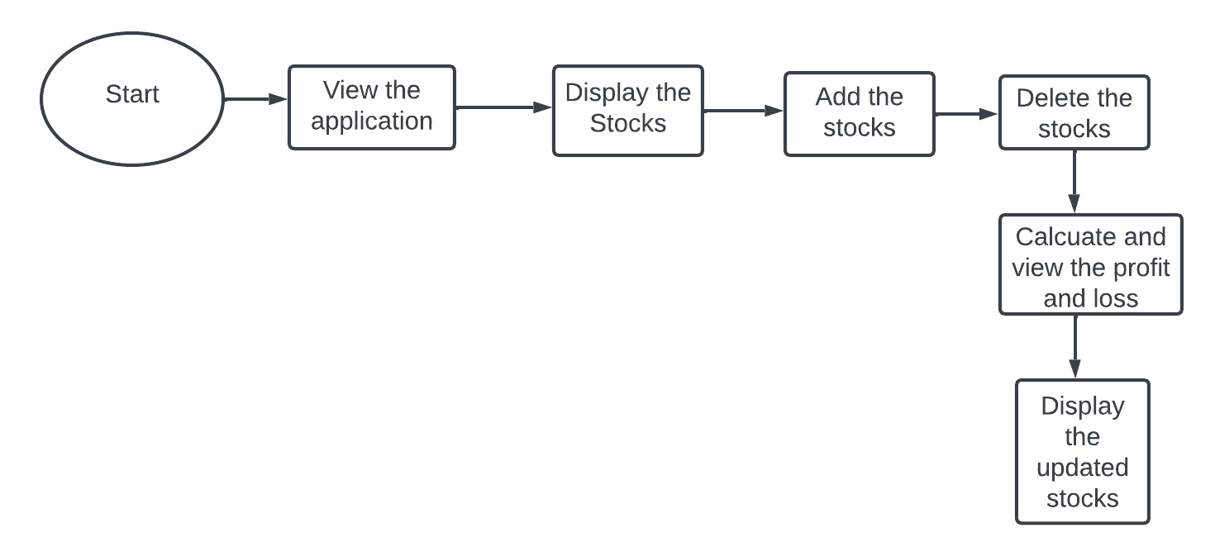

**4.2 Flow Chart of the Application**

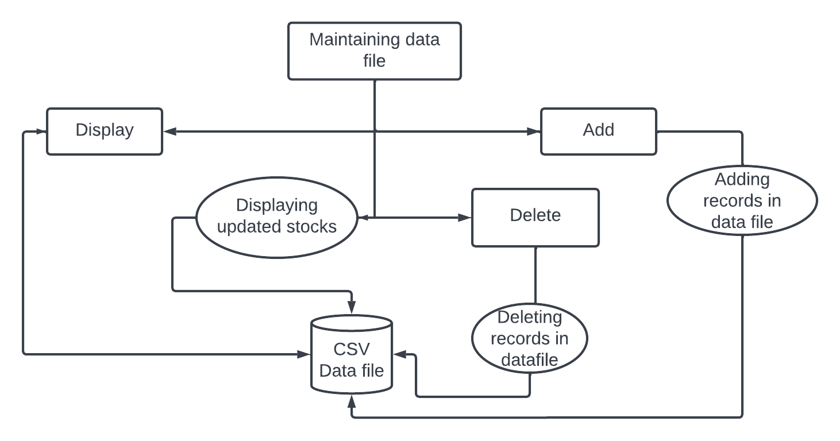

**4.2 Flow Chart for Maintaining datafile**

**4.3 Flow chart for Main menu of the application**

